**Cassandra Shell Queries**

Amit Kumar Sahu

18mis7250

**#Creating Key Space**

create keyspace cluster1

WITH replication = {'class': 'SimpleStrategy',

'replication_factor' : 3};

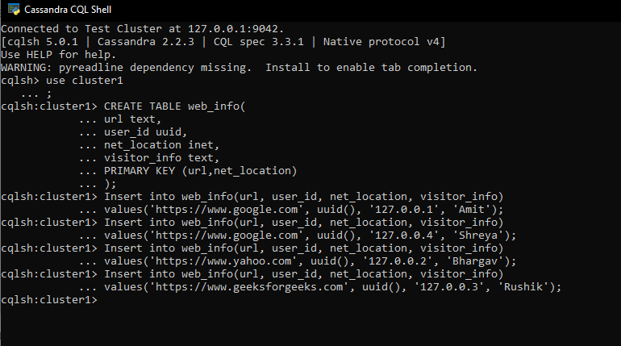

**#Capturing and storing in output file**

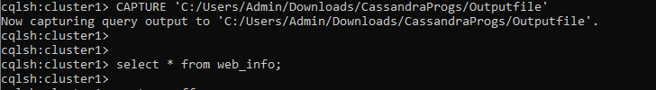

**#Screenshot of saved file**

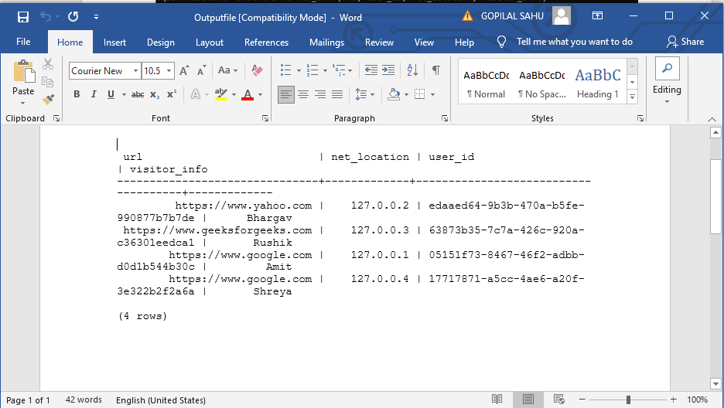

**#Queries**

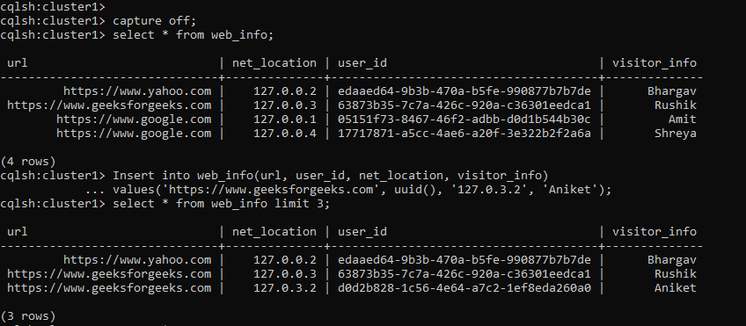

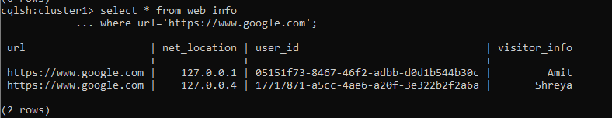

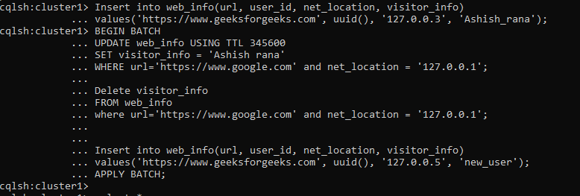

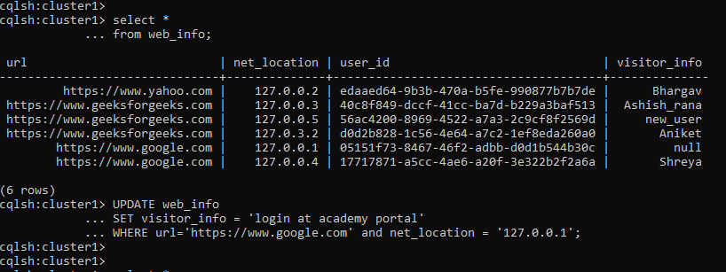

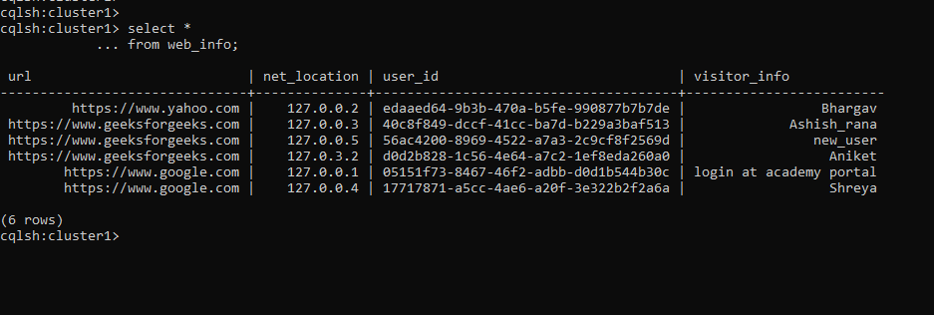

Reference: <https://www.geeksforgeeks.org/useful-cql-query-in-cassandra/>